LINUX PROGRAMMING
ASSIGNMENT 10
SUBMITTED BY : URVIJA KAPILA , 3-C , ROLL NO 11 , USN ENG24CY0063

COMMAND 1 : KILL

As its name implies, the kill command is used to terminate or kill running processes. The kill command was introduced in Version 4 of Unix in 1973. The command was used to send a signal to a process, initially just a SIGINT (interrupt signal), to "do in an unwanted process". When an application freezes and starts consuming excessive system resources (CPU or memory), then the administrators can use kill to shut it down.
The SIGKILL (signal 9) is a special, non-catchable signal that forces immediate termination as a last resort. By default, kill sends a SIGTERM (signal 15), which is a "nice" way to ask a process to terminate. This allows the application to perform cleanup operations, save data, and shut down in an orderly manner. Through signals like SIGKILL (signal 9) or SIGTERM (signal 15), kill embodies Unix's straightforward approach to system control.
Kill can send various other signals for different purposes, such as SIGHUP (1) for reloading configuration or SIGSTOP (19) to pause a process. While using kill we must keep in mind that, we must have the superuser privileges to send signals to processes that do not belong to us.
Following are the signals that can be sent by the kill command.
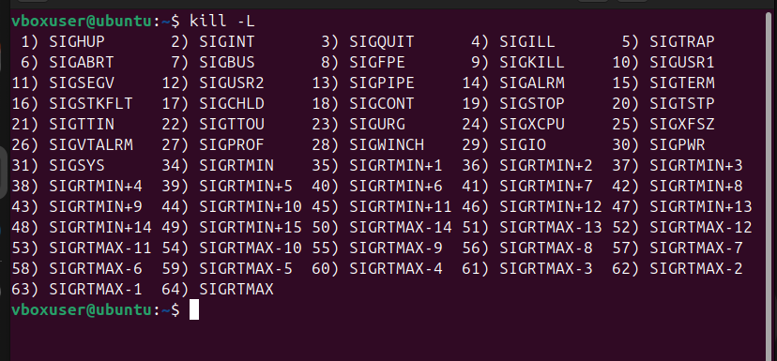
To use the kill command , we have to specify the PID (Process ID) of the process we want to terminate. This can be achieved by using the ‘pidof’ command and then using that PID in our kill command. Here’s an example:

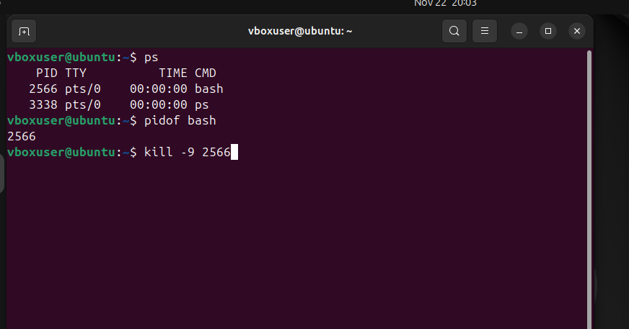
On entering the kill command, you will observe that the terminal closes.

COMMAND 2 : IP ROUTE

The ip route command in Linux belongs to the iproute2 utilities, which was authored by Alexey N Kuznetsov. The ip route command was introduced to replace the older ‘route’ command, which was part of the net-tools suite.

The ip route command is used to view and edit the routing tables.
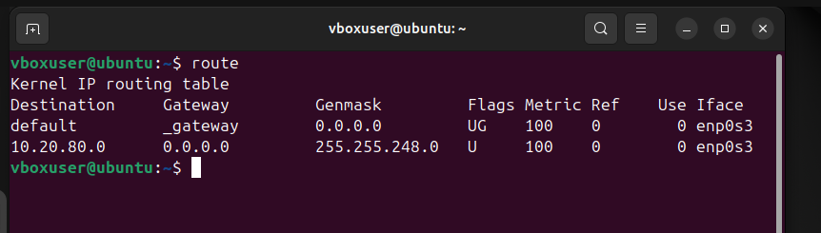
To display all routes we use the command $ ip route

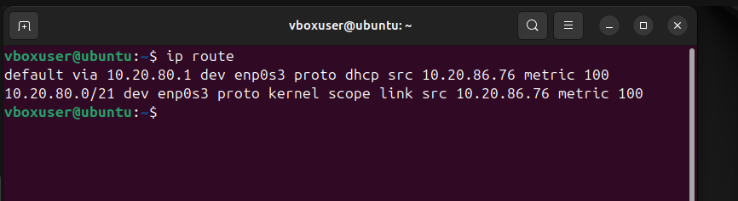
To add an ip route the syntax is:
$ sudo ip route add {NETWORK/MASK} via {GATEWAYIP}
$ sudo ip route add {NETWORK/MASK} dev {DEVICE}
$ sudo ip route add default {NETWORK/MASK} dev {DEVICE}
$ sudo ip route add default {NETWORK/MASK} via {GATEWAYIP}

Remember that, the ip route add Linux command is used to add a static route to the routing table of a Linux Kernel.

These are the examples for the following commands –

To add a default route by specifying the gateway for all outgoing traffic:
$ sudo ip route add default via 192.168.1.1

To add specific routes for particular network destinations via interface:
$ sudo ip route add 192.168.0.0/24 dev eth0

To determine which route would be used for a specific destination IP:
$ sudo ip route get to 8.8.8.8

A system administrators makes use of the ip route show (or simply ip r) to inspect the kernel's IP routing table, understanding how network traffic is directed. This helps them to identify misconfigurations or missing routes that are preventing network communication.

